多相机交叉标定精度验证
83_1:
avg_error_reproject: 9.389377
avg_error_location: 0.5642

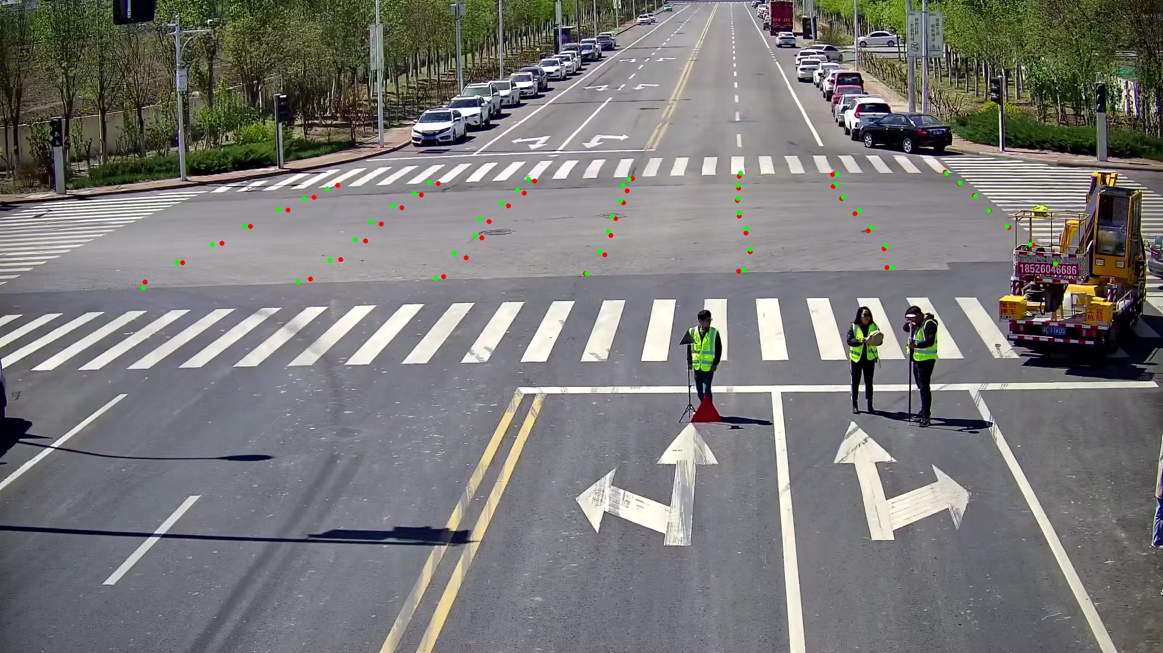

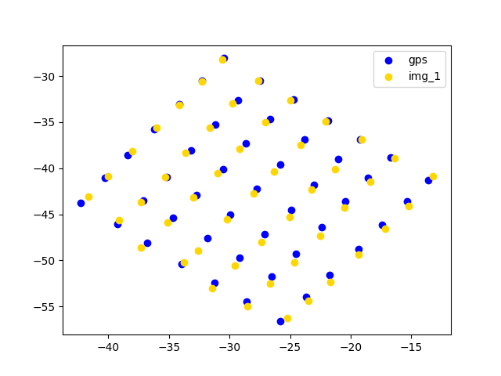
83_2:avg_error_reproject: 8.1399
avg_error_location: 0.9017

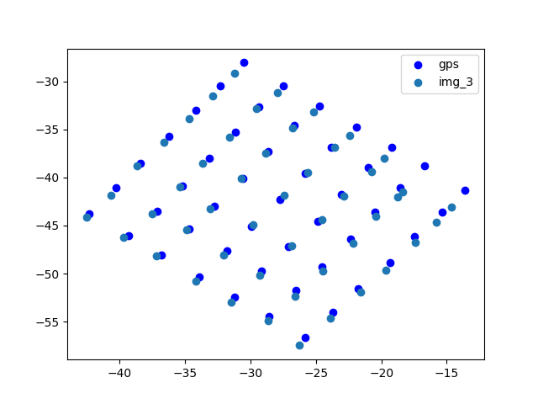
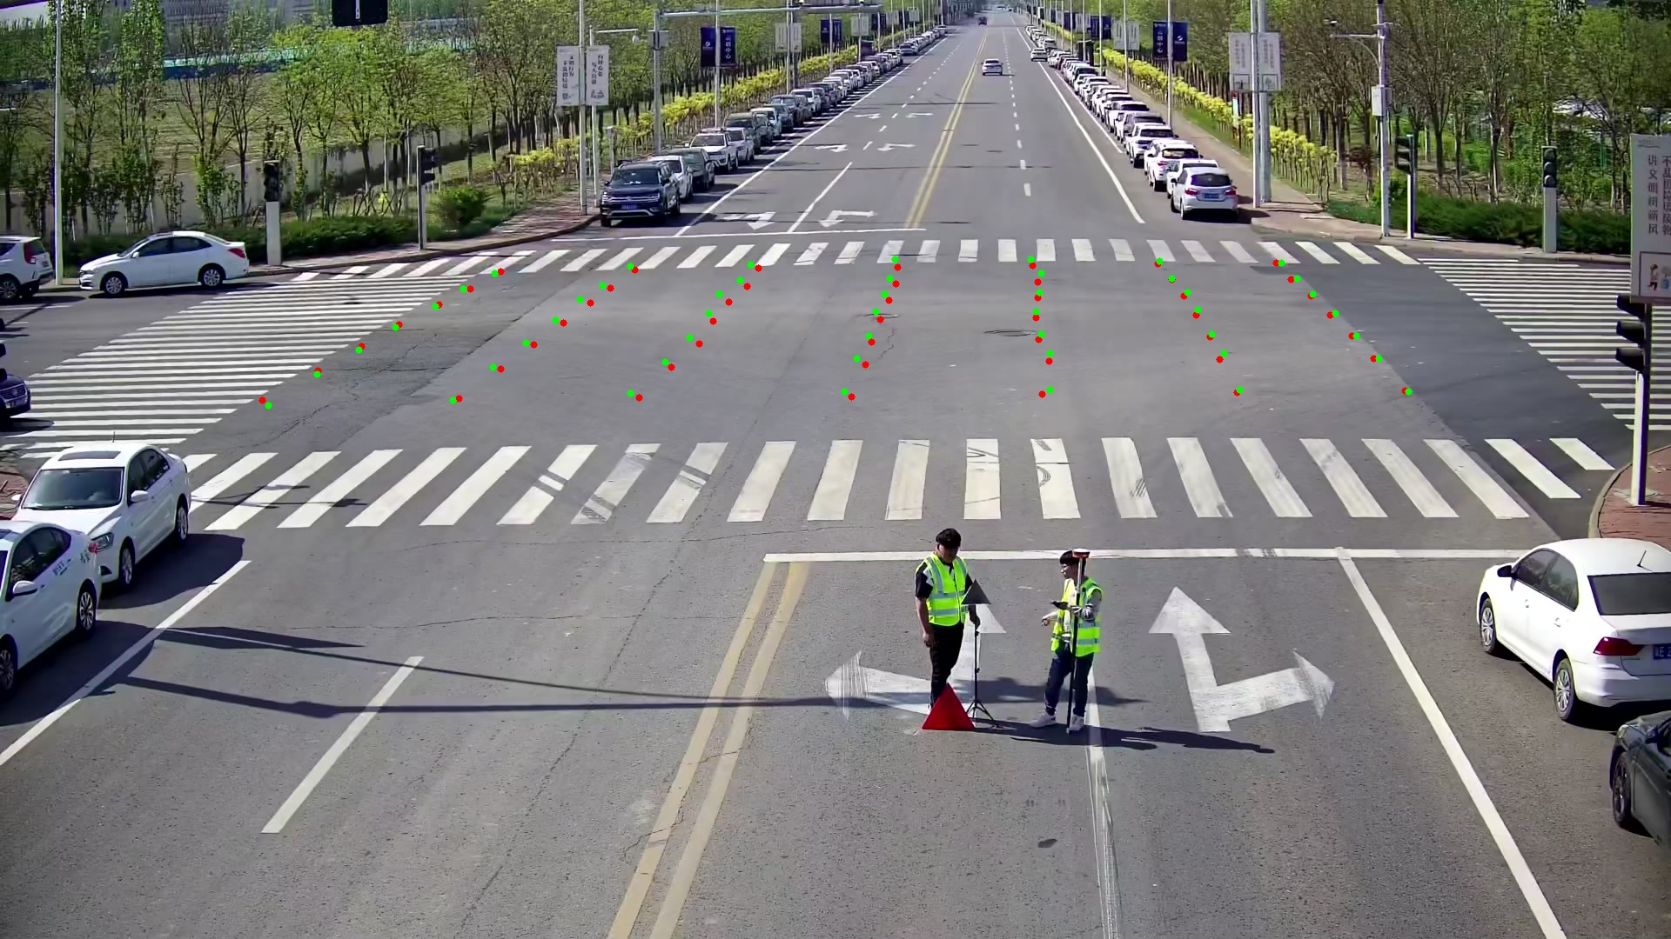

83_3：
avg_error_reproject: 11.9904
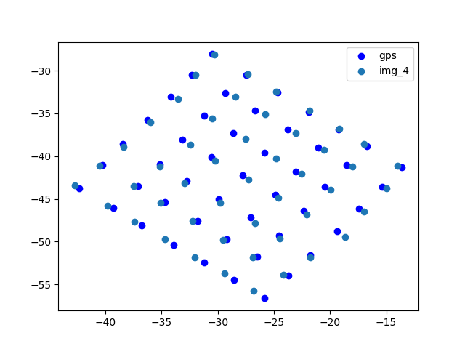
avg_error_location: 0.655

83_4:
avg_error_reproject: 7.60
avg_error_location: 0.5757

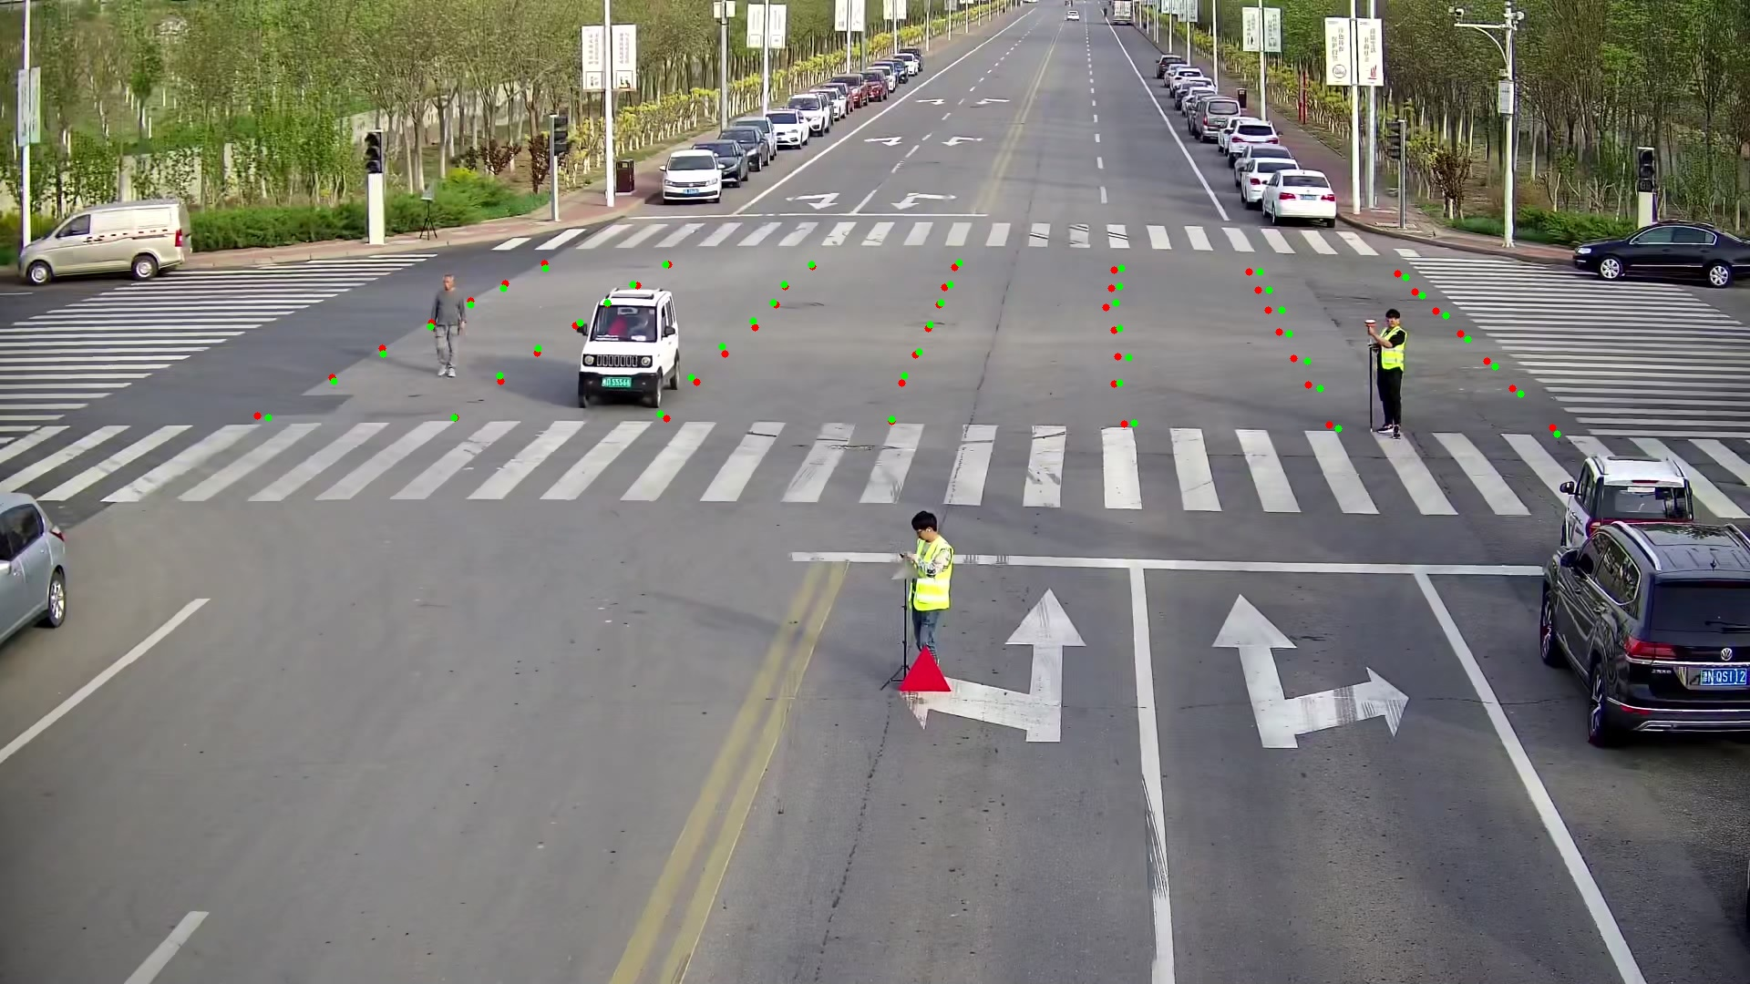
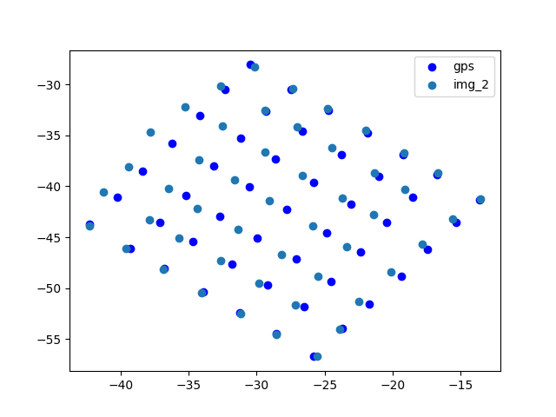

四个相机定位：

